Rittal and Eplan at the SMM 2024 in Hamburg
From the new standard in design, planning and engineering to DNV accreditations: new efficiency trends driving the maritime industry
Herborn/Monheim, 2024-08-23.
The direction of travel for tomorrow’s maritime industry is already charted today: With systematic digitalisation, standardisation and automation, shipbuilding and equipment manufacturing must constantly increase the efficiency of their value-added processes. Rittal and Eplan will demonstrate how the industry can achieve greater data consistency and also more reliably and confidently manage digital transformation at the SMM, the world’s leading maritime trade fair, taking place in Hamburg from 3 to 6 September. Maritime industry-accredited system solutions ensure greater system uptime even under the most adverse conditions.
Everything will revolve around and focus on the maritime industry's future for four days when the “Shipbuilding, Machinery & Marine Technology” (SMM) trade fair opens in Hamburg on 3 September. Rittal and Eplan present their respective involvement and activity with regard the transformation of the industry: At their exhibition stand (Hall B6, Booth 319), visitors will be able to discover the latest solutions for achieving data consistency in shipbuilding and upstream equipment design, planning, engineering and manufacture.

The engineering standard for shipbuilding and offshore, port and infrastructure applications
Eplan will showcase end-to-end solutions for complete ship operating technology. Companies can benefit from a single standard-setting system for various areas within the maritime industry: The Eplan platform offers maritime-accredited design, planning, presentation and documentation of electrical engineering, automation technology, process engineering, climate control and ventilation technology, pneumatics and hydraulics, together with project, cable and equipment management, and all this with a data-based system architecture. In this way, a completely functional digital twin can be created – from individual components to the entire ship. The software can be easily integrated into existing systems and processes to make them more streamlined and efficient: Seamless connectivity to the master plan, 3D model, PDM and ERP systems, other database systems, and the PLC or ship automation is more easy to manage. The highlight at the stand is the demonstration of a manufacturer-independent Module Type Package (MTP) workflow from design, planning and engineering through to automation without any data disruption and inconsistencies. This is being demonstrated using the Phoenix Contact MTP Designer and a live example of a GEA bilge water system.

Digital workflows in system and equipment engineering
Eplan and Rittal also provide innovative solutions for panel building and switchgear engineering and operation with digital solutions as well as system technology and automation. This way, equipment manufacturers benefit from can benefit from end-to-end seamless workflows across the entire value chain, from design and planning to system technology and from manufacturing to systems operation. With “Rittal ePocket”, the digital wiring plan pocket, Eplan and Rittal can demonstrate how the “life cycle management” of control and switchgear systems – and therefore the entire project – can now be transferred to the cloud.

First successfully DNV-tested and certified cooling units
At the SMM, Rittal will present for the first time its range of successfully DNV-tested cooling units (“Blue e+ Dynamic”) for maritime applications. Rittal has further developed its cooling solutions and specifically for dynamic loads on the high seas. In addition to the usual EMC compatibility testing for ships, vibration resistance and the safe operation of the units when tilted was also tested in particular. DNV certification means that these units operate effectively and cool both safely and reliably, even under strong dynamic loads.

Rittal will also be showcasing the benefits of the marine-accredited VX25 and AX enclosures and enclosure platforms, along with the DNV-certified VX25 Ri4Power power distribution system solution. Durable and weather-resistant outdoor enclosures, such as those used for shore power, and the latest IT infrastructure solutions, like the VX IT rack with LCP cooling, will also be on show.

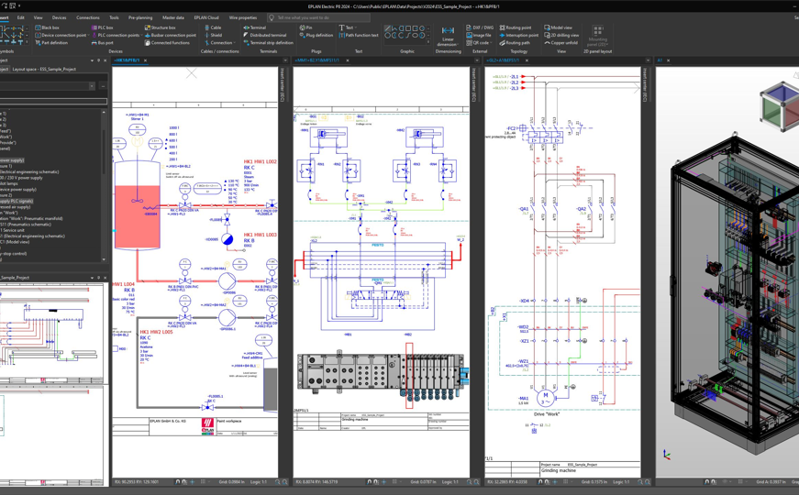 |  | 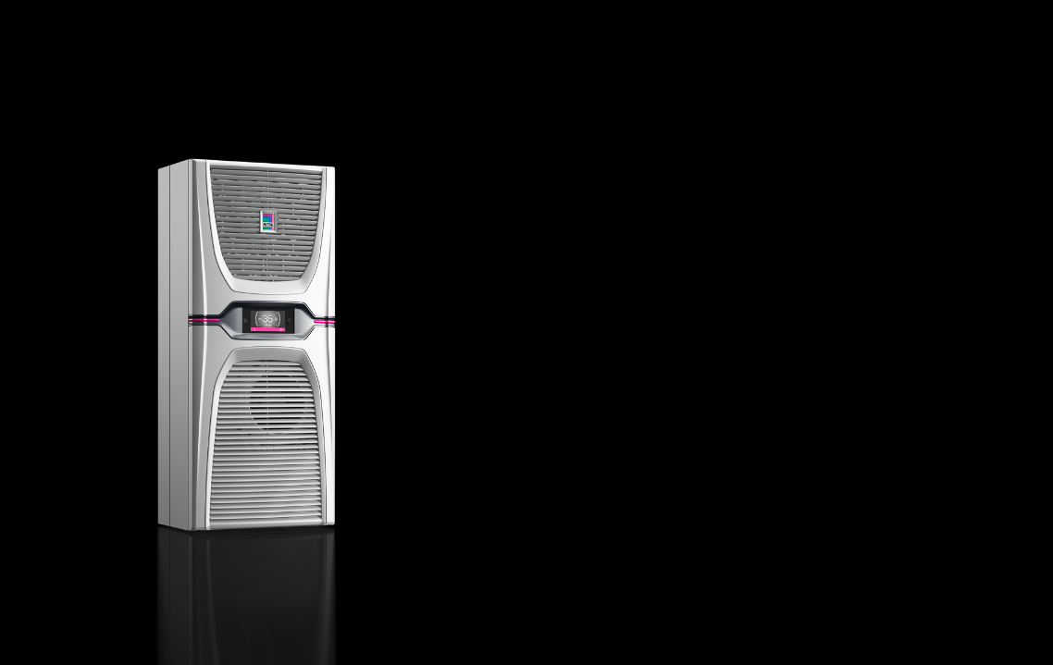
Image 1  The Eplan platform offers maritime-accredited design, visualisation, presentation and documentation of electrical engineering, automation technology, process engineering, climate control and ventilation technology, pneumatics and hydraulics, together with project, cable and equipment management, and all this with a data-based system architecture. |  | Image 2  For the first time, Rittal will present at the SMM, the range of "Blue e+ dynamic" cooling units that have been successfully DNV tested and certified for marine applications.



Image 3
The direction of travel for tomorrow’s maritime industry is already charted today: With systematic digitalisation, standardisation and automation, shipbuilding and equipment manufacturing must constantly increase the efficiency of their value-added processes. It is vital not to lose any time in the face of tough international competition.

May be reproduced free of charge. Please name Rittal GmbH & Co. KG / Eplan GmbH & Co. KG as the source.

Rittal

Rittal is a leading global supplier of enclosure systems, automation and infrastructure with its industrial, IT, energy and power, cooling and service units. Rittal products and solutions are used in over 90% of global industries – standardised, customised, and always of the very best quality.
Our approach and methodology: Rittal, Rittal Software Systems (Eplan, Cideon and German Edge Cloud) and Rittal Automation Systems (RAS, Ehrt, Alfra) combine their hardware and software expertise to streamline, optimise and digitalise processes across the entire value chain for our customers including their IT infrastructure – from control and switchgear construction, machine building to factory operators or the energy sector.
Our delivery promise: Rittal standard products are delivered in Germany within 24 hours, and within 48 hours throughout Europe.
Customer focus
Improving efficiency and increasing productivity through automation and digitalisation is one of the biggest challenges for our customers. This requires in-depth knowledge and expertise, the combination of hardware and software, and cross-sector networking. We are convinced that creating and connecting data rooms is crucial to the success of industrial transformation. And that is exactly our speciality and field of competence.
Eplan and Rittal are driving the development of the digital automation twin, making data accessible and useable in operations as well. Cideon is improving data consistency in the digital product twin context with its CAD/CAM, PDM/PLM and product configuration expertise. German Edge Cloud’s ONCITE Digital Production System (DPS) makes production process data transparent, enabling it to be optimised – right through to energy management using digital production twins.
Sustainability
Environmental and climate protection, social commitment and ethical corporate management are a given for Rittal. We take our responsibility for a sustainable future seriously. Our approach to resource management and conservation involves continuous improvement of our own production processes and ensuring that our products have the lowest possible Product Carbon Footprint. Our solutions support our customers in achieving their own climate targets.
Family business and global player
Founded in 1961, Rittal is the largest company in the owner-operated Friedhelm Loh Group. The group operates worldwide, with more than 12 production sites and over 95 international subsidiaries. It has more than 12,100 employees and posted revenues of 3 billion euros in fiscal 2023. In 2023, the Friedhelm Loh Group was presented with the “Best Place to Learn” and “Employer of the Future” awards. In 2024, Rittal was awarded the Top 100 Seal as one of Germany’s most innovative medium-sized companies for the third time in a row.
For more information, visit www.rittal.com and www.friedhelm-loh-group.com.

Corporate Communications
Dr. Carola Hilbrand Rittal GmbH & Co. KG
Corporate & Brand Communications Auf dem Stützelberg
Phone: 02772/505-2527 35745 Herborn
hilbrand.c@rittal.de www.rittal.com


Follow us:
Eplan

Eplan provides design, planning and engineering software and service solutions for all aspects of electrical, automation and mechatronic engineering. The company has developed one of the world’s leading design software solutions for machine and panel builders. Eplan is also the ideal partner to simplify and streamline complex and challenging engineering processes.
Both standardised, as well as customer-specific interfaces to ERP and PLM/PDM systems, ensure data consistency across the entire value chain. Working with Eplan means seamless communication across all engineering disciplines. Regardless of whether the company is large or small: It allows customers to use their expertise more efficiently. Worldwide, EPLAN serves and supports over 68,000 customers. Together with its customers and partners, EPLAN strives to continue growing and actively advancing integration and automation in engineering. Within the Eplan Partner Network, open interfaces and seamless integrations are implemented together with partners. “Efficient engineering” is Eplan’s core focus.
Eplan was founded in 1984 and is part of the owner-operated Friedhelm Loh Group. The group operates worldwide, with more than 12 production sites and over 95 international subsidiaries. It has more than 12,100 employees and posted revenues of 3 billion euros in fiscal 2023. In 2023, the Friedhelm Loh Group was presented with the “Best Place to Learn” and “Employer of the Future” awards.
For more information, visit www.eplan-software.com and www.friedhelm-loh-group.com.

Corporate Communications
Birgit Hagelschuer Eplan GmbH & Co. KG
Press- and public relations An der alten Ziegelei 2
Phone: 02173 3964-180 40789 Monheim am Rhein
Hagelschuer.b@eplan.de www.eplan.com

Follow us:

